Lease No. U-

EMPLOYEE HOUSING AGREEMENT

THIS EMPLOYEE HOUSING AGREEMENT (the “Agreement”) is entered into effective as of the date of last signature below by and between Regents of the University of Minnesota, a Minnesota constitutional corporation (the "University"), and (the “Employee”). This Agreement is entered into by University through its .

1. The Premises. University, in consideration of the rents and covenants contained in this Agreement, does lease to Employee, and Employee does rent from University the following described premises, situated in County, Minnesota, and described as follows:

A single family dwelling with without garage, with an address of (the “Residence”) located at the (the “Facility”).

2. Term. Employee shall have the right to occupy the Residence beginning on , 20 and ending on the earlier of any one of the following: (i) as provided in Section 15; (ii) the date on which Employee’s employment with University is terminated; or (iii) upon 30 days’ notice from one party to the other.

3. Use. The Residence is leased to Employee for residential purposes only. Employee shall not use the Residence or Facility for the purpose of carrying on any business, profession or trade of any kind. As a condition of Employee’s use and occupation of the Residence, Employee shall be required to be available at all times and act responsibly in emergencies at the Facility, including, but not limited to, fire, severe storms and tornadoes, power outages and water line breakage, as more fully described in Exhibit A.

4. Utilities and Services. University will provide heat, electricity, sewer/water services, trash removal and major maintenance and repairs for the Residence. Employee will deposit trash and recyclable materials in the designated trash receptacles and will keep the Residence in good clean condition and order.

5. Rent and Services in Lieu of Rent. The rental value of the Residence is $ per month. Monthly rent for Employee’s use of Residence during the Term shall be paid as follows: (i) the payment of $ payable on the first day of each month, and (ii) the performance of the services described in Exhibit A valued at $ annually, which shall be deemed to have been paid in 12 equal payments of $ for purposes of reporting income, withholding taxes and other purposes. The value of the services performed by Employee shall be subject to applicable state and federal income taxes and deductions. University shall have the right to recalculate the rental value of the Residence, the cost of utilities, and/or the value of services upon not less than 30 days’ notice to Employee, as of January 1 of any year during the Term.

Employee’s failure to pay rent within 10 days of the due date will result in a late payment charge of 8% of the overdue rent. Payments which are more than 30 days late shall accrue interest on the unpaid amount at the rate of 12% per annum or 1% per month from the date due until payment is made. Payments received will be applied first to the late charge, then to interest, and then to rent.

6. Pets. No pets are allowed in the Residence or at the Facility.

7. Legal Compliance. Employee use and possession of the Residence is subject to applicable federal, state and local laws, ordinances, rules and regulations, as well as all applicable University policies, rules and regulations, including the University policy on the Possession or Carrying of Weapons, a copy of which is attached as Exhibit B, and the University policy on Smoke and Tobacco Free Campus: Crookston, Duluth, Rochester, and Twin Cities, a copy of which is attached as Exhibit C.

8. Hazardous Materials. Except as needed to perform the services described in Exhibit A, Employee shall not keep or have any dangerous articles, flammable fluids or explosive or hazardous or toxic substances on or about the Residence or Facility.

9. Right of Entry. University shall have the right at all reasonable times during the term of this Agreement to enter and inspect the Residence.

10. Personal Property. University is not responsible under any circumstances for damage to or loss of Employee’s personal property.

11. Indemnification. Employee agrees to release, indemnify and hold harmless University from any and all claims for loss of or damage to property or bodily injury, including personal injury, to persons arising out of the use of the Residence by Employee or Employee’s invitees.

12. Insurance. Employee shall purchase and maintain in force during the term of this Agreement renters or apartment insurance covering Employee’s personal property located in the Residence, and which shall include general liability insurance in an amount not less than $300,000 combined single limit covering bodily and personal injury and property damage, including contractual liability specifically covering the obligations of the Employee under the above indemnification clause. Employee shall provide a Certificate of Insurance evidencing such coverages and naming Regents of the University of Minnesota as an additional insured.

13. Assignment. Employee shall not assign this Agreement or sublet the Employee’s space in the Residence.

14. Obligations at End of Agreement. Employee will, at the expiration or earlier termination of this Agreement, leave the Residence in as good a condition as when it took them, ordinary wear and tear and damage from the elements excepted. The Residence shall not be altered by the Employee in any way, including marring the surface of walls or furniture with tacks, nails, tape, or similar substances.

15. Default. If Employee fails to timely perform all non-emergency services, University shall have the right, upon 30 days written notice, to terminate this Agreement and all obligations of the parties set forth in this Agreement shall cease on such date of termination. If Employee defaults in any material term or condition hereof or if Employee fails to timely respond to an emergency at the Residence or Facility, University shall have the right to terminate this Agreement immediately.

16. Amendment. This Agreement may be extended in writing by the mutual agreement of the parties.

17. Notices. Notices required hereunder shall be sent to the Employee at the Residence and to University as set forth below:

To University:
Attn:

Phone: ( )
Facsimile No.: ( )
Email:

With a copy of notices to: Regents of the University of Minnesota
c/o Real Estate Office
Attn: Leasing Manager
Suite 451, Donhowe Building
319-15th Avenue SE
Minneapolis, MN 55455-0199
Facsimile No.: (612) 624-6345
Email: reo@umn.edu

IN WITNESS WHEREOF, University and Employee execute this Employee Housing Agreement.

Regents of the University of Minnesota  By:  Name:  Title:  Date: | Employee  By:  Signature  Date:

EXHIBIT A
Employee Rental Justification

Location:
Property Description:
Employee:
Utilities & Services supplied by University: Electricity, natural gas, garbage pickup
Utilities supplied by Employee: phone
Service supplied by Employee:

 | $
 | $
 | $
TOTAL | $
Calculation of Rent:
Market Rent (12 mos. @ $ /month)  Property Taxes Assessed (If None, enter 0) | $  $
Heat, sewer, water & garbage pickup (12 mos. @ $ /month) | $
TOTAL | $
Minus hours of service @ $ /hr | ($ )
ANNUAL RENT
$ /12 months = $ /month | $
RENTAL AMOUNT
$ /month

EXHIBIT B
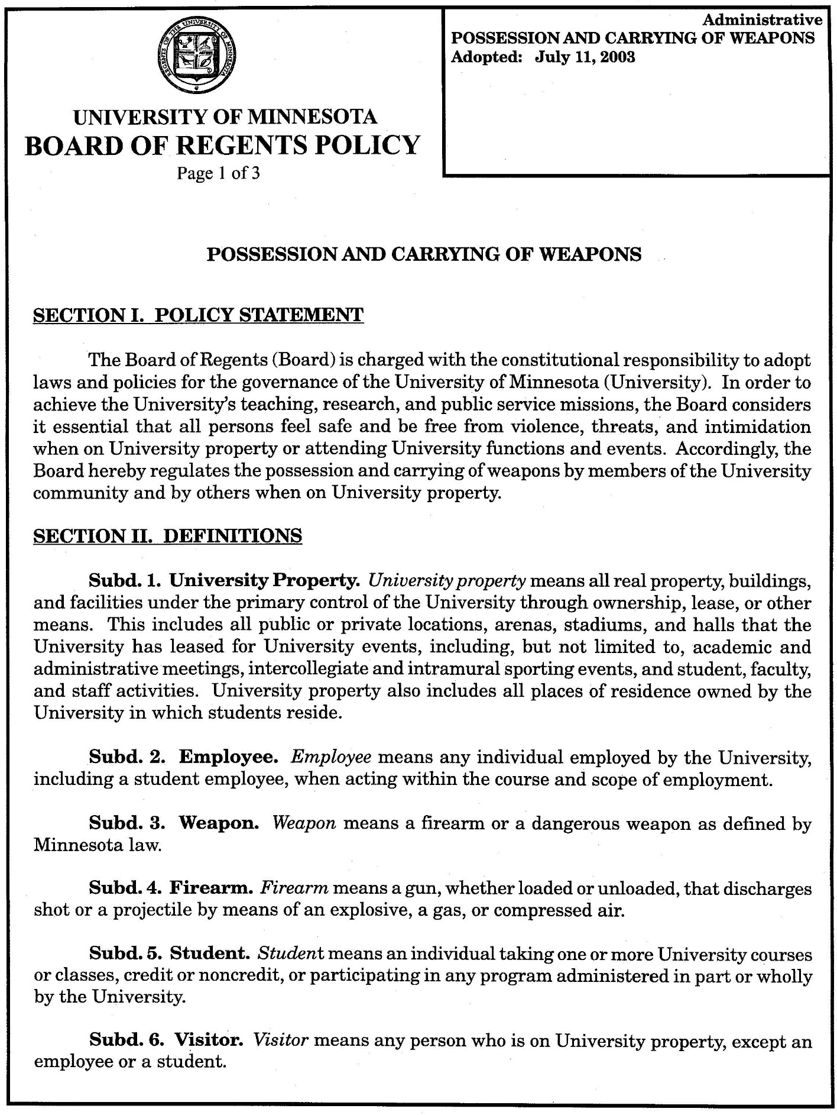
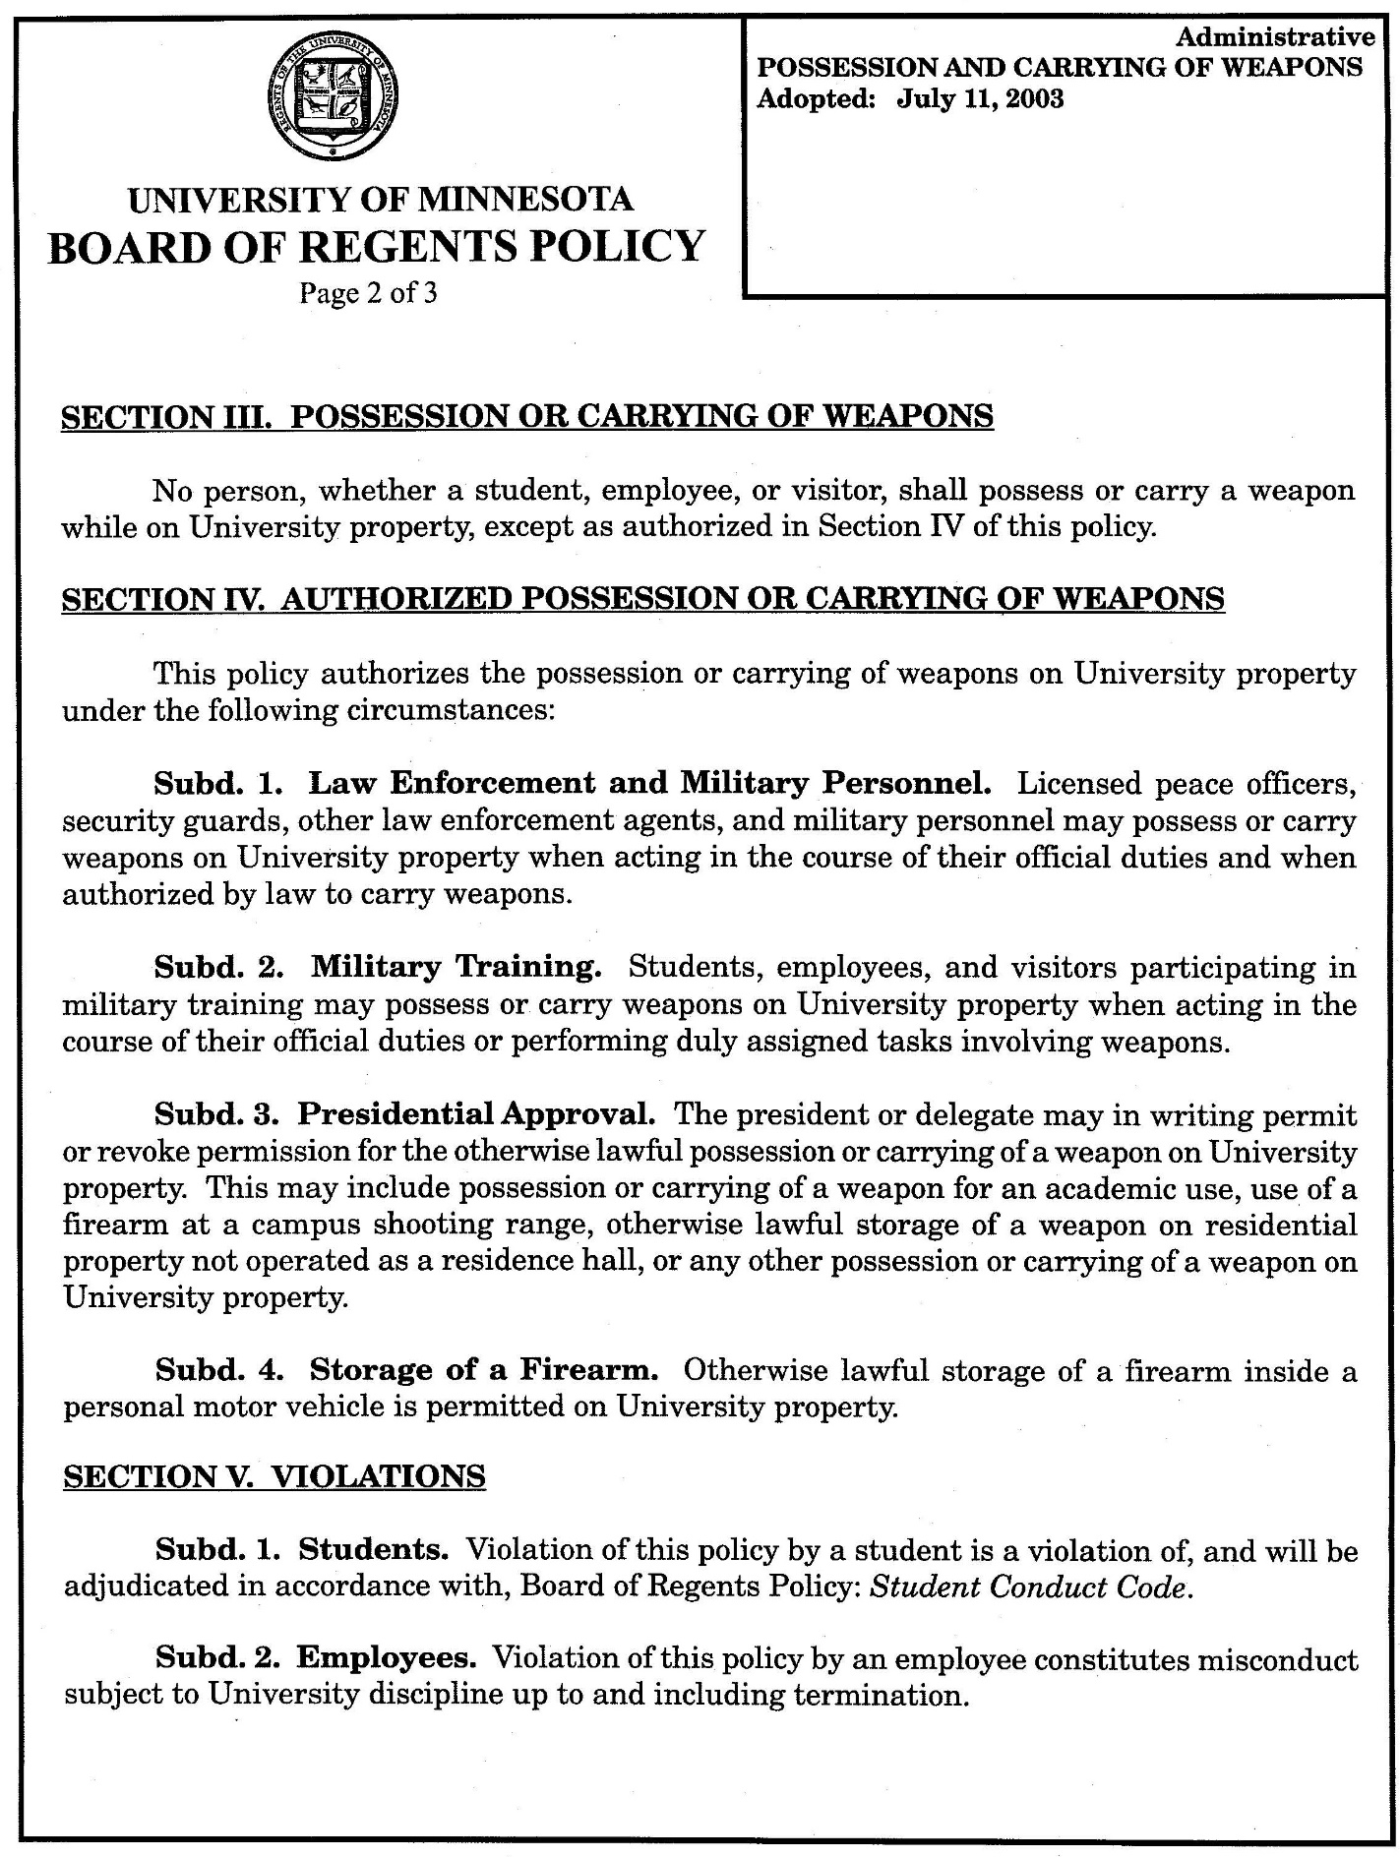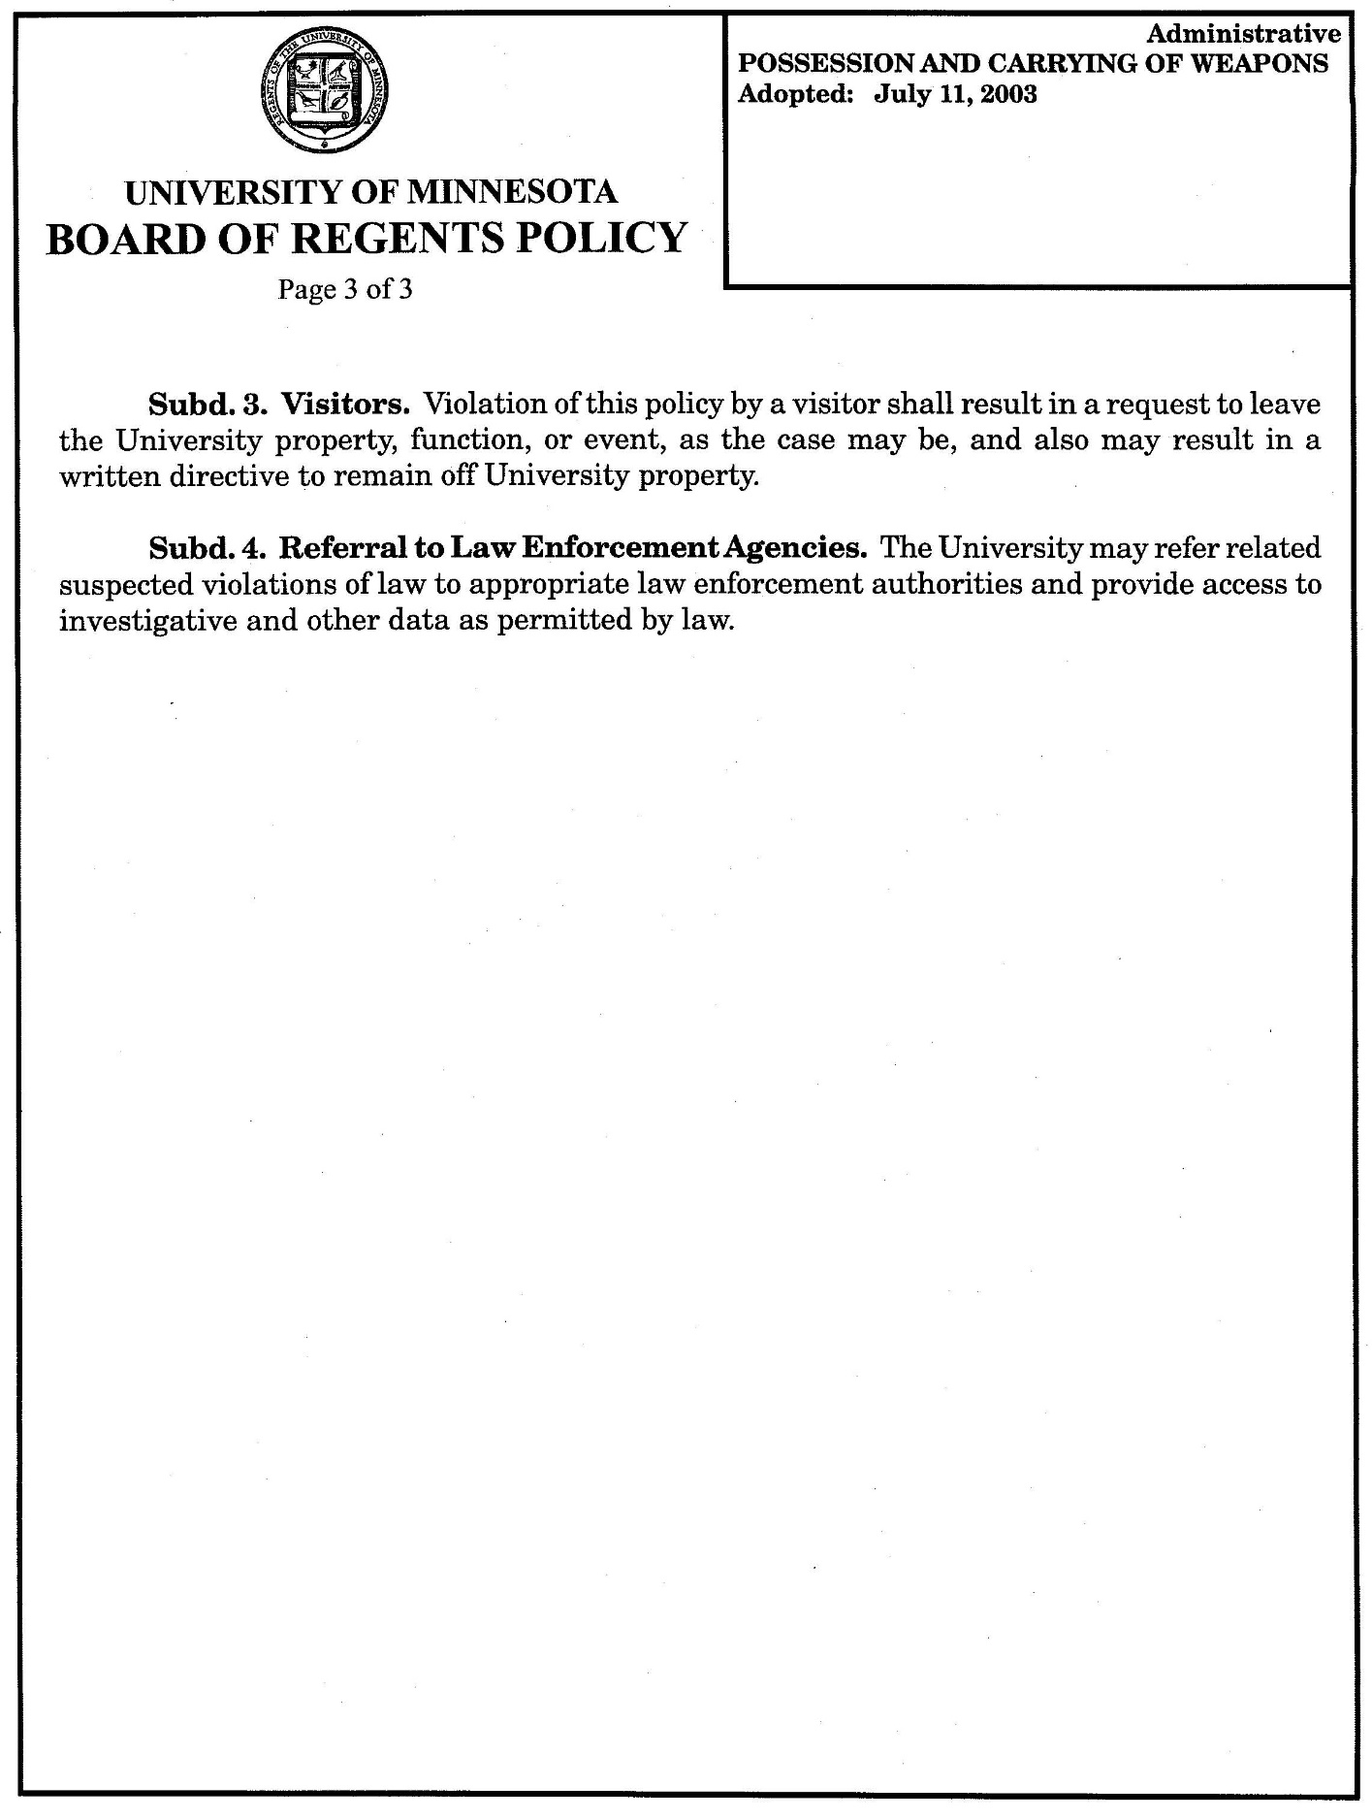

EXHIBIT C
