FACILITY AND HOUSING AGREEMENT

NORTH CENTRAL RESEARCH AND OUTREACH CENTER

THIS FACILITY AND HOUSING AGREEMENT (“Agreement”) is entered into on , by and between Regents of the University of Minnesota, a Minnesota constitutional corporation (“University”), and , a (“Licensee”). This Agreement is entered into by University through its College of Food, Agricultural and Natural Resource Sciences and the North Central Research and Outreach Center (“NCROC)”.

1. Facility. University owns and operates the NCROC located at 1861 Highway 169 East in Grand Rapids, Minnesota, which includes overnight bedrooms, conference rooms, a lunchroom, and outdoor areas (forest trails and roads and forested stands) (all together, the “Facility”).

2. Use. University grants to Licensee the right to use the Facility for the purpose of .

2.1 Licensee’s use shall include the following areas of the Facility (complete as applicable):

2.1.1 Licensee shall be assigned to the following bedroom(s): . Licensee’s use of bedroom(s) will be exclusive. The following space(s) will be shared with other Licensees: (i) kitchen, (ii) living room, (iii) bathroom, (iv) laundry.

2.1.2 Licensee’s use of the Facility includes use of the following spaces .

2.1.3 Use of the outdoor areas is shared with other guests at the Facility, provided that Licensee shall have exclusive use of the following outdoor areas, which are shown on attached Exhibit A (Forest Trails and Roads) and/or Exhibit B (Stand Map):

2.2 Licensee shall use the Facility in accordance with the terms and conditions of this Agreement, all University policies and regulations (including Safety of Minors, smoking, alcohol and weapons), Facility rules attached to this Agreement as Exhibit C, and all federal, state and local laws, ordinances, rules and regulations. University policies and regulations and Facility rules are subject to change without notice. In addition, Licensee agrees to use the Facility in accordance with all guidance published by the Centers for Disease Control and Prevention (CDC), the Minnesota Department of Health (MDH), and University related to the safe use of the Facility. The foregoing specifically includes, but is not limited to, all CDC, MDH and University guidance related to COVID-19.

2.3 The Facility is provided in “AS IS” condition, and University is under no obligation to make any alterations, additions, improvements, or decoration in or to the Facility.

2.4 Licensee shall not install, use, generate, store, or dispose of in or about the Facility any hazardous substance, toxic chemical, pollutant, or other material regulated by the Comprehensive Environmental Response, Compensation and Liability Act of 1985 or the Minnesota Environmental Response and Liability Act or any similar law or regulation, including without limitation any material containing asbestos or PCBs (collectively “Hazardous Materials”) without University’s written approval of each Hazardous Material. Licensee shall indemnify, defend and hold University harmless from and against any claim, damage, or expense arising out of Licensee’s installation, use, generation, storage, or disposal of any Hazardous Materials, regardless of whether University has approved the activity.

3. Term.

3.1 Licensee shall have the right to use the Facility from through (the “Term”). This Agreement may be extended in writing by mutual agreement of the parties, provided that, if Licensee is an entity or organization (i.e., non-individual), Licensee’s use of the Facility pursuant to this Agreement shall not exceed 50 separate calendar days.

3.2 If Licensee or any of its attendees, members, guests or invitees fails to keep any term of this Agreement, a Facility rule, or any University policy or regulation, University may terminate this Agreement and Licensee shall be required to vacate the Facility immediately.

4. Fees. Licensee shall pay a fee for use of the Facility as follows:

$_____ for conference and facility room(s).

$____ for outdoor space(s).

$____ per person per night for housing.

Unless otherwise agreed in writing, all fees and applicable sales tax are due and payable as follows: .

5. Cancellation. Licensee may cancel this Agreement at any time prior to arrival without penalty.

6. University’s Reservation of Rights.

6.1 University may re-assign or move Licensee or its guest(s) to another bedroom, conference room, or outdoor facility (as applicable) at the Facility from time to time and upon notice to Licensee, and Licensee agrees that upon receipt of such notice, Licensee shall—or shall cause its guest(s) to—cease use of the bedroom or other Facility space then in use or previously assigned and shall comply with the terms of this Agreement with respect to the new bedroom or other Facility space.

6.2 University shall have the right to enter, pass through, and examine the Facility for the purposes of (i) inspecting or making repairs, additions, or alterations; (ii) ensuring health, fire and safety regulations are observed; (iii) as part of check in/check out procedures; or (iv) for any other reasonable purpose.
6.3 In exercising its rights under this section, University shall, when feasible, provide Licensee with reasonable prior notice of University’s activities, and shall make a reasonable effort to minimize the resulting interference with the conduct of Licensee’s business.

7. Food Preparation/Meals. If the Facility includes use of a bedroom, Licensee will have access to shared kitchen space for preparation of food/meals by Licensee and/or Licensee’s guests. Licensee must supply its own food.

8. Release, Indemnification. Licensee agrees to release, defend, indemnify, and hold harmless University from and against any and all liability, claims, injuries, loss, damage, actions, fines, costs and expenses of any kind or nature whatsoever (including reasonable attorneys’ fees) arising out of or caused by Licensee and Licensee’s family, guests, employees, agents, assigns, visitors or invitees in their use of the Facility.

9. Insurance. At least 30 days prior to commencement of the Term, Licensee shall provide University with a certificate of insurance or other acceptable evidence of insurance coverage as indicated below. If this Agreement is signed by Licensee fewer than 30 days prior to commencement of the Term, Licensee shall submit such evidence of insurance upon the signing of this Agreement.

9.1. Check either (A), (B), (C) or (D) below as applicable:

(A) Licensee’s policy of Commercial General Liability Insurance with a minimum limit of $1,000,000 per occurrence; or qualified self-insurance subject to approval by University.

(B) Proof that Licensee has purchased event liability insurance with a minimum limit of $1,000,000 per occurrence. Licensee may purchase such insurance from the insurer of its choice, or at the following website address: https://tulip.ajgrms.com.

(C) State and other governmental agencies that are self–insured shall provide a letter stating that fact and the coverage limits for such insurance on departmental letterhead.

(D) Licensee is an individual person, including a University faculty member, staff member, student, or other individual (whether University-affiliated or non-affiliated), and exempt from this requirement.

9.2 Workers’ Compensation/Employers Liability, if applicable, to the extent required by law.

9.3 All insurance provided under paragraph 9.1(A) and 9.1(B) shall be written by insurance companies with an A.M. Best rating of A-VII or better and licensed and authorized to do business in the State of Minnesota and shall name Regents of the University of Minnesota as an additional insured. The policies shall provide that the insurance coverage shall not be canceled, modified or non-renewed before the end of the term of this Agreement without written notice to University. Licensee shall maintain the insurance(s) described in this paragraph for the entire term of this Agreement.

10. Personal Property. Licensee, not University, is responsible for loss of or damage to any personal property of Licensee, its guests, agents, employees or invitees, located within the Facility before, during or after the Term of this Agreement.

11. Utilities, Services, Alterations. University shall provide the following utilities and services: heat, electricity, sewer/water services, and trash and recycling removal. Licensee shall deposit trash and recyclable materials in the receptacles designated by University and shall keep the Facility in good clean condition and order. Licensee shall not alter the Facility in any way, including marring the surface of walls, furniture, with tacks, nails, tapes, or disturbing the natural environment.

12. License Only; Remedies. Licensee acknowledges that this Agreement represents a grant of a revocable license only, and not an easement or lease. Licensee shall pay to University all of University’s damages, costs and fees, including attorneys’ fees, caused by Licensee’s failure to comply with the terms and conditions of this Agreement. In addition, if Licensee fails to comply with the terms and conditions of this Agreement, University shall be entitled to exercise all other legal and equitable remedies available to University.

13. Guests or Assignment. Licensee shall not, without the prior written consent of University in each instance, (a) permit visitors or guests of Licensee to stay overnight; (b) assign this Agreement; or (c) permit another to use the Facility. Licensees are not permitted to occupy any other bedroom in the Facility, nor switch bedroom assignments with other Licensees without University’s prior written consent to such change.

14. Obligations at End of Agreement. Licensee shall, upon the expiration or earlier termination of this Agreement or upon reassignment of cabins as provided above, cease use of the Facility, leaving it in as good a condition as when it took it, ordinary wear and tear and damage from the elements excepted, and remove all of its property therefrom. Property not removed by Licensee will be considered abandoned, and University may dispose of it as it deems expedient without liability to Licensee or others.

15. Notices. Notices required by this Agreement shall be sent to the Licensee at or by email at and to the University c/o the NCROC, 1861 Highway 169 East, Grand Rapids, Minnesota 55744 or by email at NCROC@umn.edu.

16. Cancellation Due to Uncontrollable Event. This Agreement may be canceled by either party if an Uncontrollable Event makes it impracticable or inadvisable to use the Facility for the purposes described in this Agreement. An “Uncontrollable Event” means an event or circumstance that is beyond the reasonable control and without the fault of the party impacted. An Uncontrollable Event may include, but is not limited to, an act of God; civil disorder; terrorist acts or threats; acts of governing authorities; fires, floods, and other natural disasters; strikes or other labor difficulties; public health issues or disease; facility closings or operation disruptions due to severe weather, a failure or disruption of utilities or critical equipment, an active shooter, or other emergencies; or other events, whether similar or dissimilar to the foregoing. For clarity, an Uncontrollable Event will include the COVID-19 pandemic and related circumstances, whether or not foreseeable (including, without limitation, ongoing or new quarantine orders; employee travel or other restrictions; University campus closure or policy changes; or federal, state, or local governmental orders or advisories). If this Agreement is cancelled due to an Uncontrollable Event, neither party shall have any liability to the other, provided that amounts paid by one party to the other shall be promptly refunded except that Licensee shall be responsible for the fees related its use of the Facility prior to the date of cancellation and shall reimburse University for all reasonable expenses incurred to the time of cancellation (including any expenses for which University then is and will remain unavoidably committed).

17. Governing Law; Forum. The laws of the state of Minnesota shall govern the validity, construction and enforceability of this Agreement. All suits, actions, claims and causes of action relating to the construction, validity, performance and enforcement of this Agreement shall be brought in the state courts of Minnesota.

18. Limitation of University Liability. IN NO EVENT SHALL UNIVERSITY BE LIABLE FOR ANY INDIRECT, CONSEQUENTIAL, INCIDENTAL, LOST PROFITS OR LIKE EXPECTANCY DAMAGES ARISING OUT OF THIS AGREEMENT. UNIVERSITY’S TOTAL LIABILITY FOR BREACH OF THIS AGREEMENT IS THE TOTAL OF THE FEE PAYABLE BY LICENSEE SET FORTH IN SECTION 4.

19. Non-Waiver; Survival. No waiver by any party of a default or non-performance by the other party shall be deemed a waiver of any subsequent default or non-performance. Licensee’s obligations under Sections 8, 10, 12, and 14 and University’s limitation of liability under Section 18 shall survive the expiration or earlier termination of this Agreement.

20. Counterparts; Electronic Signatures. This Agreement may be executed in counterparts and/or by electronic signature, each counterpart of which will be deemed an original, and all of which together will constitute one Agreement. The executed counterparts of this Agreement may be delivered by electronic means, such as email, and the receiving party may rely on the receipt of such executed counterpart as if the original had been received.

21. Exhibits. The terms and conditions of any and all exhibits and addenda attached to this Agreement are made a part of this Agreement as if fully set forth in this Agreement. To the extent that any of the terms and conditions of Sections 1-21 of this Agreement conflict with any of the terms and conditions of the attached exhibits and addenda, the terms and conditions of the exhibits and addenda will control. All capitalized terms in any exhibits and addenda that are not specifically defined in such exhibits and addenda will have the meanings given them in this Agreement.

IN WITNESS WHEREOF, University and Licensee have executed this Agreement as of the day and year first above written.

Regents of the University of Minnesota

By: By:
Name: Name:
Title: Title:
Date: Date:

EXHIBIT A

Forest Trails and Roads

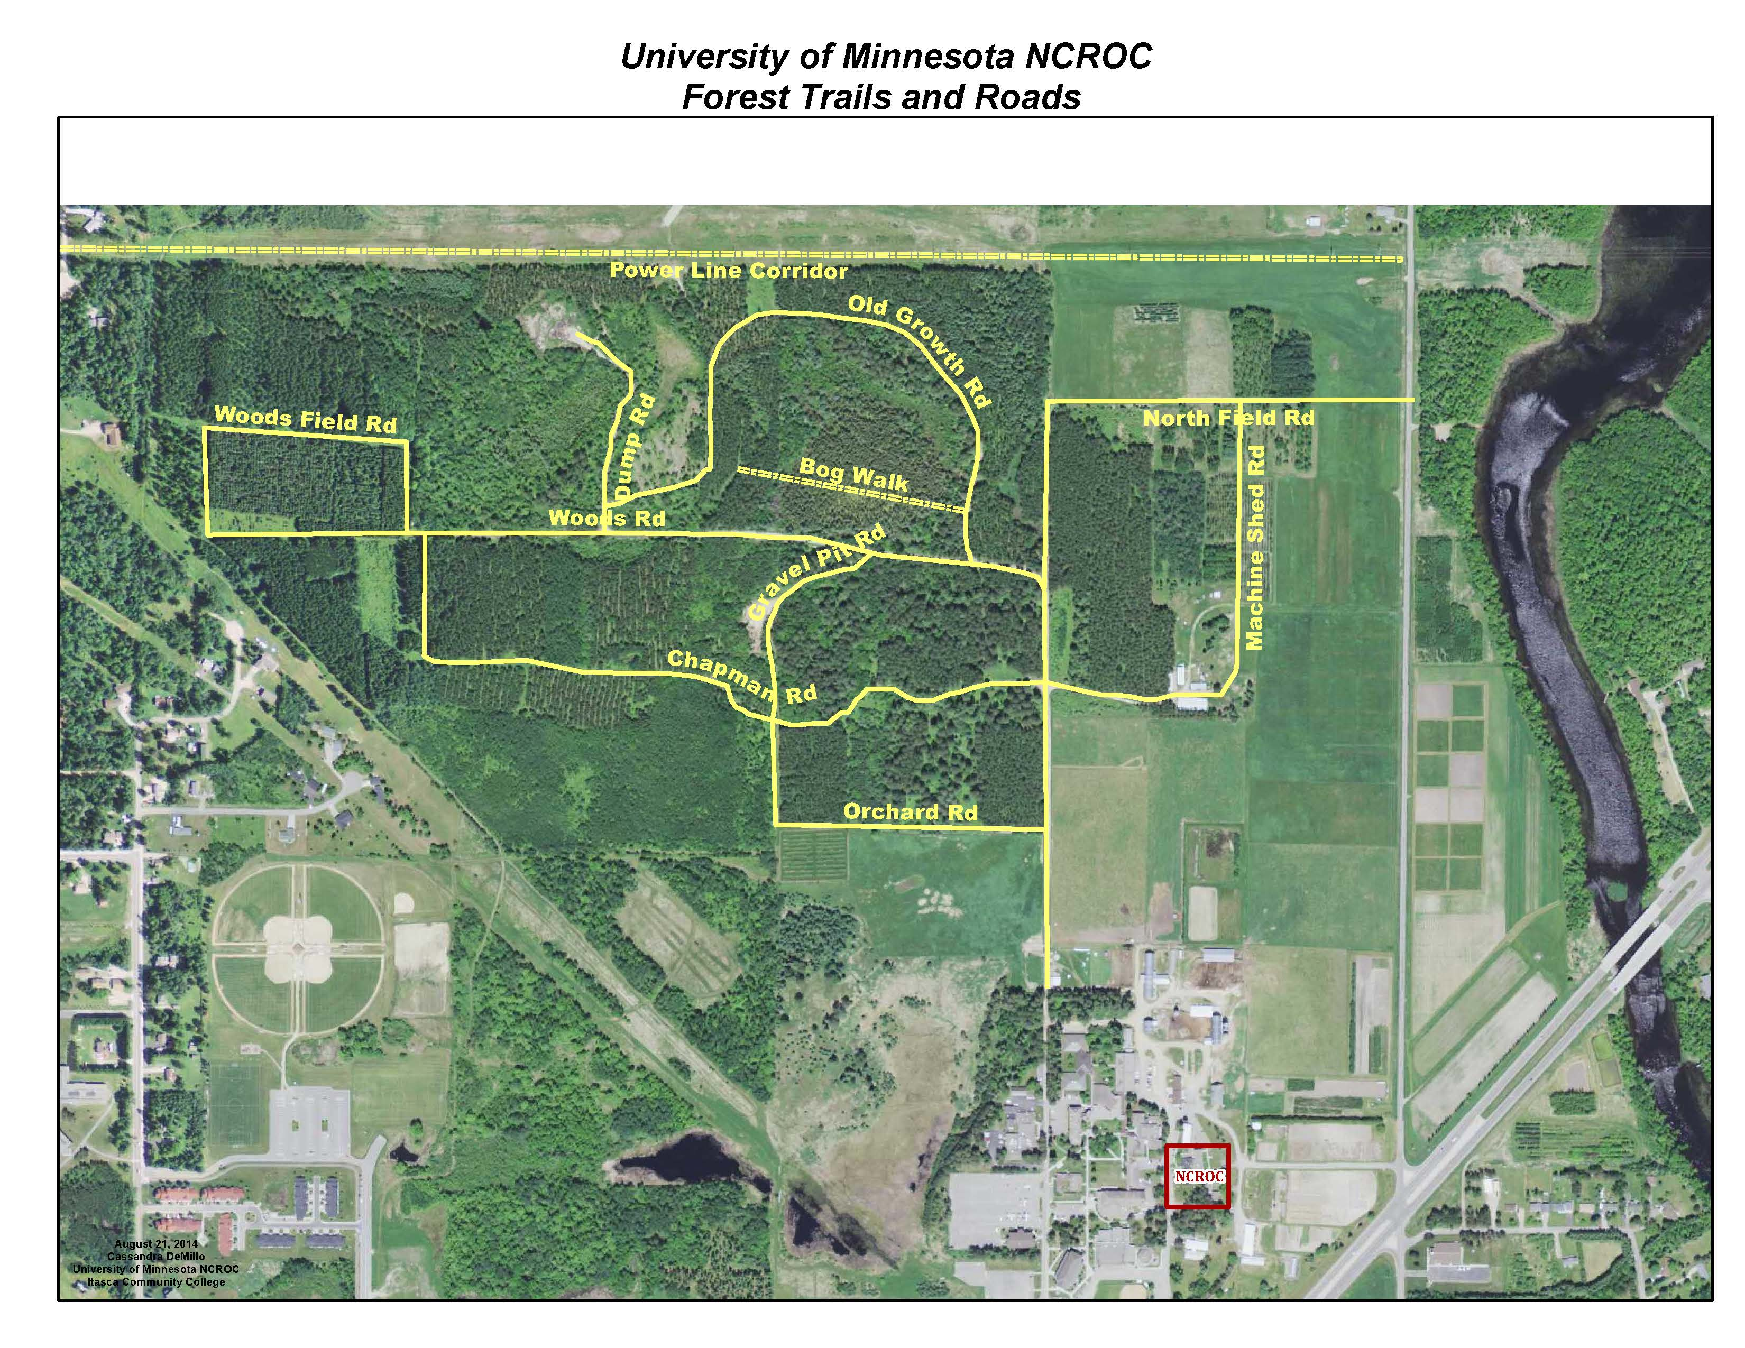

EXHIBIT B

Stand Map

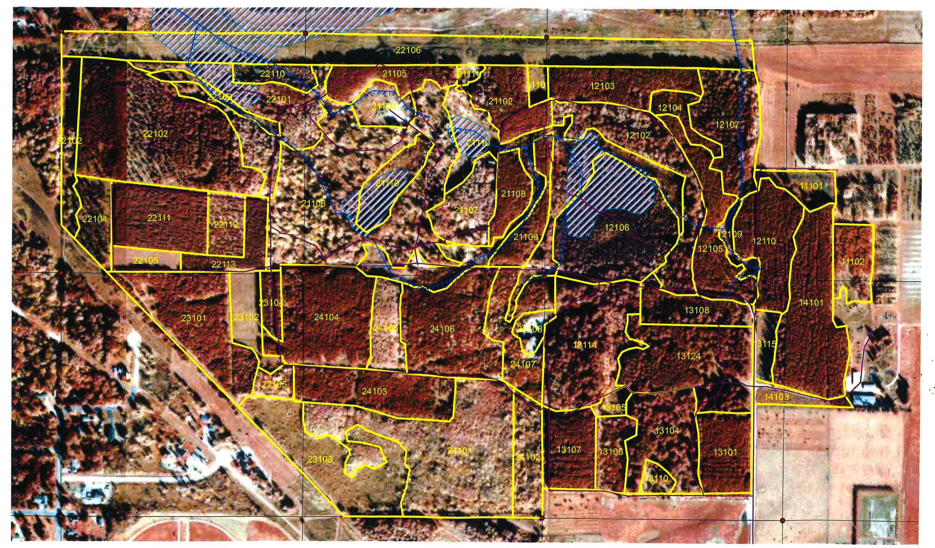

EXHIBIT C

North Central Research and Outreach Center Rules and Guidelines

