Lease No. U-453

CEDAR CREEK SUMMER HOUSING AGREEMENT

FOR RESEARCHERS, STUDENTS AND STAFF

THIS SUMMER HOUSING AGREEMENT (the “Housing Agreement”) is entered into effective as of , by and between Regents of the University of Minnesota (“University”), a Minnesota constitutional corporation, and (the “Occupant”). This Agreement is entered into by University through the College of Biological Sciences and its Cedar Creek Ecosystem Science Reserve.

1. Residence. University grants to Occupant the right to use dormitory space (“Dormitory”) and/or house/lodge space (“House/Lodge”) located at the Cedar Creek Ecosystem Science Reserve, 2660 Fawn Lake Drive NE, East Bethel, Minnesota, 55005 (the “Facility”), providing for the private and/or shared use as checked below:

Private bedroom, shared bathroom, kitchen, living room and remainder of House/Lodge;

Shared bedroom [with one other], shared bathroom, kitchen, living room and remainder of House/Lodge;

Bed(s) in dormitory room, shared bathroom and kitchen in Dormitory;

Private campsite, shared bathroom and kitchen in Dormitory;

Shared campsite, shared bathroom and kitchen in Dormitory;

(all those checked are together referred to as the “Residence”) at the Facility, during the period of through , for occupancy by University of Minnesota Faculty/Staff, University of Minnesota Student, or Other
, in accordance with the terms and conditions contained in this Agreement, Facility Rules and Guidelines attached to this Agreement as Exhibit A, applicable University policies, rules and regulations and federal, state and local laws and ordinances. Either party may terminate this Agreement at any time during the occupancy period upon ( ) days’ prior written notice to the other party.

2. Use of Residence. Occupant shall use the Residence for residential purposes only. From time to time during the term of this Housing Agreement upon notice to Occupant, University may assign, move, or re-assign Occupant to another space at the Facility, and Occupant agrees that upon receipt of such a notice, Occupant will surrender possession of the space then occupied and will comply with the terms of this Housing Agreement with respect to such new space.

Occupant is not permitted to occupy any other room in a Dormitory or House/Lodge, nor switch room assignments with other occupants without University’s prior written consent to such change.

3. Utilities and Services. University will provide heat, electricity, sewer/water services, trash removal and major maintenance and repairs for the Residence. Occupant will deposit trash and recyclable materials in the designated trash receptacles and will keep the Residence in good clean condition and order throughout the term of this Housing Agreement.

4. University’s Reservation of Rights. University shall have the right to enter, pass through, and examine the Facility for the purposes of (i) inspecting or making repairs, additions or alterations, (ii) ensuring health, fire and safety regulations are observed, (iii) as part of check in/check out procedures, or (iv) for any other reasonable purpose. In exercising its rights under this section, University shall, when feasible, provide Licensee with reasonable prior notice of University’s activities and shall make a reasonable effort to minimize the resulting interference with Licensee’s use of the Residence.

5. Fee. Occupant shall pay University, a fee for use of the Residence and services, including taxes, if any, $ per week, pro-rated for shorter periods, said fee due in advance or upon receipt of an invoice. The fee for occupancy periods of less than 30 days is subject to applicable sales and use tax.

6. Animals. No pets are allowed in the Residence or at the Facility. Service and/or companion animals are permitted in accordance with applicable law.

7. Firearms. Possession of firearms at the Facility or in the Residence is expressly prohibited. A violation of this provision may result in immediate termination of this Housing Agreement.

8. Indemnification; Insurance. Occupant agrees at all times to be responsible for the safety of Occupant’s guests and their respective belongings. Occupant agrees to hold harmless and indemnify University against any and all liabilities, losses, costs and damages, including property damage, personal and bodily injury, damage or loss to or caused by Occupant, Occupant’s family, guests, employees, agents, assigns, subtenants, visitors or licensees, or loss or damage to any property of said persons in or about the Facility from any cause whatsoever. Occupant is encouraged to carry Renter’s Insurance to protect against such losses.

9. Assignment; Sublease. Occupant shall not assign this Housing Agreement or sublet the Residence.

10. Obligations at End of Agreement. Upon expiration or termination of this Housing Agreement or upon the reassignment of space as provided herein, Occupant shall remove all of its personal property and cease use of the Residence, leaving it in good clean condition (including the kitchen in which all equipment and utensils will be cleaned and properly stored), ordinary wear and tear and damage from the elements excepted. Property not removed by Occupant will be considered abandoned, and University may dispose of it as it deems expedient without liability to Occupant or others. Occupant shall not alter the Facility in any way, including marring the surface of walls or furniture, with tacks, nails, tapes, or disturbing the natural environment.

11. Authority. Occupant warrants and affirms Occupant has full power and lawful authority to enter into this Housing Agreement.

12. Default.

12.1. In the event of Occupant default of any term or condition hereof, University shall have the option of terminating the Housing Agreement immediately.

12.2. In the event of University default of any term or condition of this Housing Agreement, the sole remedy of Occupant shall be the termination of this Housing Agreement and a refund of the fee attributable to such failure to perform, and in no event shall University be liable to Occupant or others for any damages, of whatever nature, including but not limited to, consequential, direct, indirect, general or lost profits.

13. Extension of Housing Agreement. This Housing Agreement may be extended in writing by the mutual agreement of the parties.

14. Notices. Notices required hereunder shall be sent to Occupant at the Residence and to University c/o Cedar Creek Ecosystem Science Reserve, 2660 Fawn Lake Drive NE, East Bethel, MN 55005-9718.

15. Not a Lease. This Agreement establishes only the right to use the Residence in accordance with its terms and conditions and does not create a lease, sublease or easement of the Residence.

IN WITNESS WHEREOF, University and Occupant have executed this Housing Agreement the day and year first above written.

Regents of the University of Minnesota  By:  Name:  Title:  Date: | Occupant  Signature:  Print Name:  Print Date:

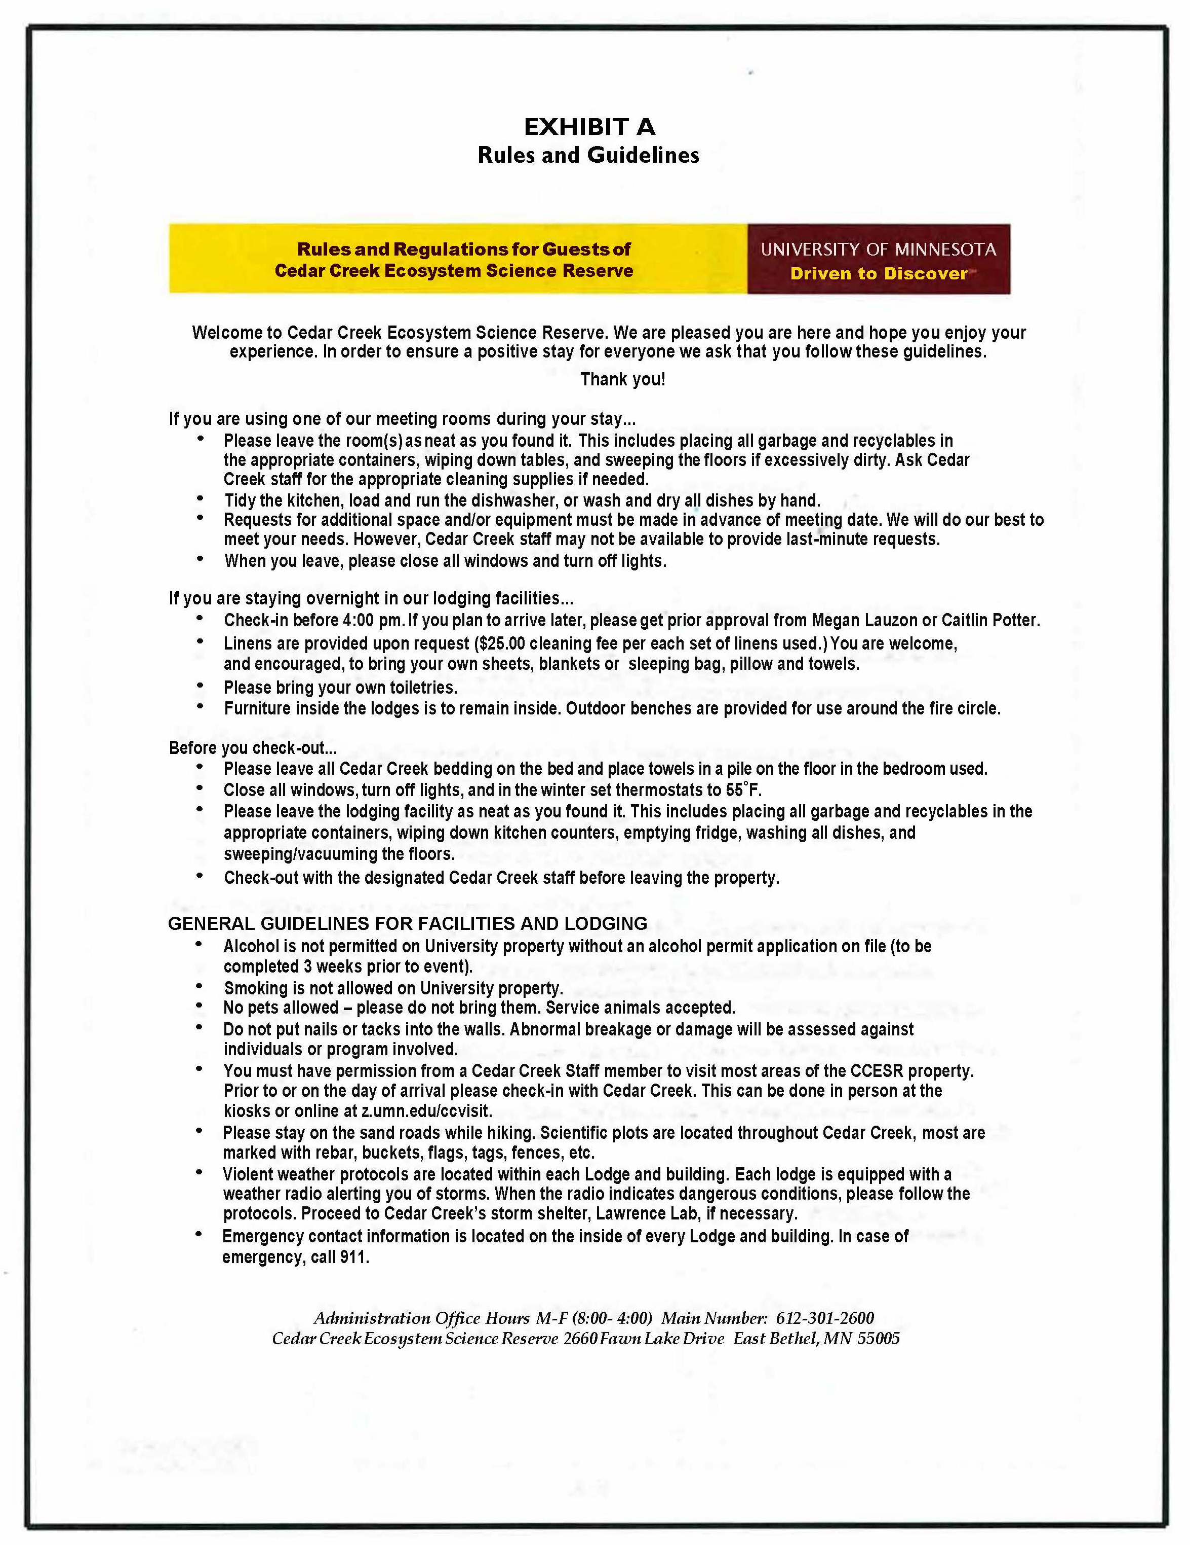

CEDAR CREEK ECOSYSTEM SCIENCE RESERVE (“Facility”)

REGISTRATION CARD

Licensee/Guest (Enter Name of Organization or Individual; attach attendee list, if applicable)
Lodge/Room(s) [insert building/room names/numbers]
Dates of Occupancy (“Term”)
State law requires every adult guest staying overnight at the Facility (including attendees, family members and guests) to complete and sign a Registration Card.
By signing this Registration Card, Organization/individual agrees that Organization/individual received, read, and understands the Facility and Housing Agreement and agrees to be legally responsible for complying with the provisions of Facility and Housing Agreement and all University and Facility policies and regulations.

Print Name
Title (if signing on behalf of Organization)
Signature _________________________________________________________________
Date _______________________________

