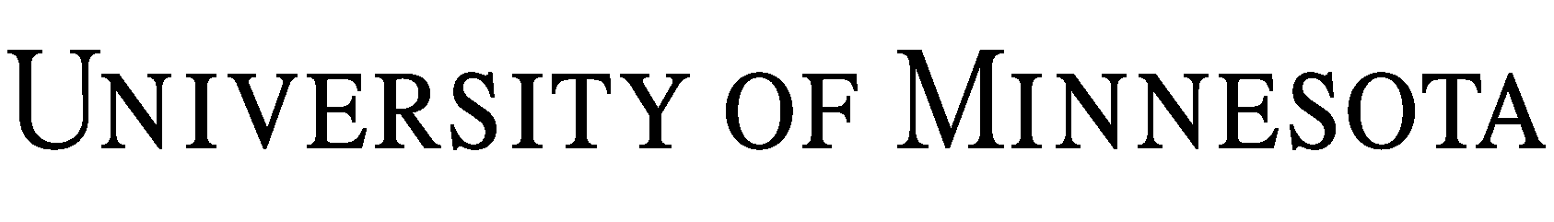

Instructional Materials Ownership and Use Agreement

THIS INSTRUCTIONAL MATERIALS OWNERSHIP AND USE AGREEMENT (“Agreement”) is made as of the Effective Date described below, and by and between Regents of the University of Minnesota, a constitutional educational corporation under the laws of the state of Minnesota, and the individuals described as Authors below.

Purpose

In this Agreement, the Authors, who created the Instructional Materials outside of the terms of this Agreement, grant the University the nonexclusive right and license to use the Instructional Materials, that the University agrees to pay the Authors for the granting of the right and license.

Effective Date:

Academic Unit:

Author(s):

Instructional Materials:

Compensation: and /100 ($ ).

NOW THEREFORE, the Author(s) and the University agree that:

1. Use of the Instructional Materials.

1.1. Subject to the terms of this Agreement, the Author(s) grant the University a nonexclusive, world-wide, perpetual, irrevocable, fully paid-up right and license to reproduce, distribute, publicly display, prepare derivative works of or otherwise use the Instructional Materials. The University shall have the further right to grant other academic institutions a sublicense of such right and license.

1.2. Except for the right and license granted the University in section 2.1 above, the Author(s) retain all copyright and other intellectual property rights they have in the Instructional Materials. Specifically, the Authors(s) retain the right to reproduce, distribute, publicly display, prepare derivative works of or otherwise use the Instructional Materials in their research, teaching or consulting activities.

2. Compensation. Within sixty (60) days after the Effective Date, the University shall deliver to the Author(s) its check(s) in the amount of the Compensation.

3. Representations, Warranties and Indemnities.

3.1. Each Author represents and warrants to the University that: (i) the Author created the Instructional Materials solely or in collaboration with the other Authors only; (ii) the Author has not assigned to or granted any person any right or license in or to the Instructional Materials that would conflict with the rights granted to the University in this Agreement; and (iii) to the Author’s actual knowledge, the Instructional Materials do not infringe the rights of (including copyrights or other intellectual property rights or privacy rights) or defame, libel or slander any person.

3.2. The Author(s) shall indemnify and hold the University and its regents, employees, and agents harmless from any suit, cause of action, claim, demand, liability, judgment, damage award, cost or expense (including reasonable attorneys’ fees) arising out of or related to the misrepresentation or breach by an Author of any warranty provided in this Agreement. This obligation to indemnify and hold harmless shall not apply to any suit, cause of action, claim, demand, liability, judgment, damage award, cost or expense arising out of the University’s intentional or negligent acts or omissions. This obligation to indemnify and hold harmless shall not apply to any suit, cause of action, claim, or demand initially made after the fifth (5th) anniversary of the date of this Agreement. Liability under this section for monetary compensatory damages shall be limited to the amount of compensation paid to or owed to the Author(s) under this Agreement.

4. Term and Termination.

4.1 The term of this Agreement is indefinite, commencing on the Effective Date and ending on the date of termination as provided below in section 4.2.

4.2 If a party fails to perform an obligation under this Agreement, the other party may deliver to the non-performing party a written notice of default. The University may terminate this Agreement if an Author fails to cure a default within thirty (30) days after the delivery of a written notice of default. The Authors may terminate this Agreement if all the Authors so agree and the University fails to cure a default within thirty (30) days after the delivery to it of a written notice of default.

5. General Terms. This Agreement is intended by the parties as the final and binding expression of their agreement and the complete and exclusive statement of its terms. It cancels all prior negotiations, representations and agreements of the parties relating to the subject matter of this Agreement. This Agreement may be amended only in a writing signed by the parties. A party may assign rights and obligations under this Agreement only with the prior written consent of the other party. The laws of the state of Minnesota, without giving effect to its conflict of laws provisions, shall govern the interpretation of this Agreement.

IN WITNESS WHEREOF, the parties, by their signatures, hereby evidence their agreement to the terms set forth above.

Regents of the University of Minnesota  By:  Name:  Title:  Date: | Author(s)  By:  Name:  Title:  Date:
By:
Name:
Title:
Date:

