For Internal Use Only  Depts must provide: |  |  | For Internal Use Only  OES must provide:
ESAF # |  |  | OES Contract #
Chart/Field Account # | - - |  | Analyst
Customer ID #

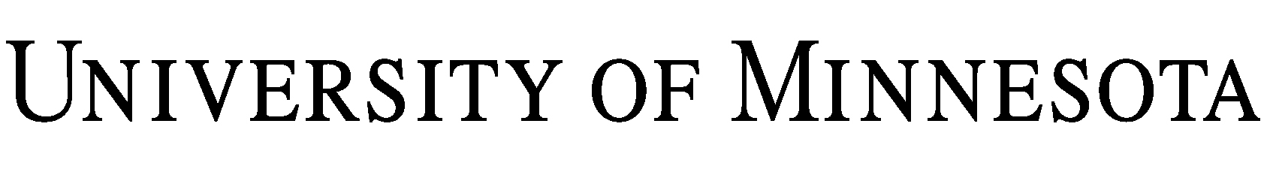
Workshop/Presentation Agreement

The Regents of the University of Minnesota, through its (“University”), agree to provide a workshop/presentation for , a (“Company”), on the following terms and conditions:

1. Description of Workshop/Presentation:

2. Date, Location, and Time:
Date:
Location:
Time:

3. Payment Terms: For the services under Section 1., Company shall pay University and /100 dollars ($ ), plus any sales and use tax. Payment is due on the day of the workshop/presentation or upon receipt of invoice. In the event Company cancels for any reason, except for extraordinary causes beyond the reasonable control of Company, Company shall remain obligated for the full amount set forth in this paragraph.

4. Obligations of Company. Company agrees to provide the following accommodations, equipment, and material:

5. Ownership of Materials and Presentation. All materials provided by University during the presentation shall remain the property of University. Company is provided a license to use the material in connection with the workshop/presentation, but Company may not copy or distribute the material without the express written consent of University. University further owns all rights to the workshop/presentation and the workshop/presentation shall not be recorded or taped in any form without the express written consent of University.

6. Disclaimer. University makes no claims of any kind with respect to the workshop/presentation and shall not be liable for participant’s reliance on any statements or demonstrations made during the workshop/presentation. University’s maximum obligation to Company for any cause of action arising under this Agreement, including failure to perform, shall not exceed the amount actually paid to University by Company under Section 3.

7. Complete Agreement/Governing Law. This Agreement, including any attached exhibits, represents the complete agreement of the parties. No amendments to this Agreement shall be binding upon University unless signed by an authorized University representative. This Agreement cancels, supersedes and revokes all prior negotiations, representations, and agreements between the parties, whether oral or written, relating to the subject matter of this Agreement. The terms and conditions of any purchase order or similar document submitted by Company in connection with the services provided under this Agreement shall not be binding upon University. This Agreement shall be governed by the laws of Minnesota and any action to enforce this Agreement shall be brought only in Hennepin County, Minnesota.

IN WITNESS WHEREOF, the parties have entered into the Agreement effective .

Regents of the University of Minnesota  By:  Name:  Title:  Date: | By:  Name:  Title:  Date:

