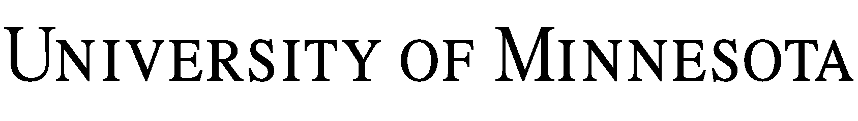

PARTICIPANT RELEASE OF LIABILITY – READ BEFORE SIGNING

(University completes this section):
Program: Department Conducting Program:

Program Activities (including transportation, if any):

I, , wish to participate in the Program described above. In consideration of being allowed to participate way in the Program, I agree:

1. Risks.

- The risks of the activities involved in this Program and Program Activities (together the “Activity) are significant, including the potential for permanent injury, paralysis and death. Rules, equipment, and personal discipline may reduce the risks, but the risk of serious injury and death will continue to exist.

- I understand that, by participating in the Activity I may be exposed to COVID or another communicable disease (“Disease”). By participating in the Activity, I assume the risk for me, my personal representatives, heirs, and next of kin, that I will be exposed to and contract a Disease and, if that were to happen, that I may require hospitalization or other medical treatment and may be temporarily or permanently injured or disabled or may die. I also assume the risk that I could pass the Disease to others. I agree to take reasonable steps to lessen my risk of exposure to a Disease. By participating in the Activity, I warrant that, to my actual knowledge, I and any individuals living with me are not infected with a suspected, diagnosed, or confirmed case of a Disease and are not exhibiting symptoms of a Disease. I also warrant that I have not been directed to quarantine or isolate at any point during the duration of the Activity. If at any point during the duration of the Activity I am directed to quarantine or isolate, I will stay home, and I will not be entitled to a refund in any amount.

- I also understand that public health conditions or state or federal guidance may change at any time, necessitating a modification to or a cancellation of the Activity. In the event of a modification to or cancellation of the Activity, the University will communicate with me as promptly as possible and share options for participation in the Activity. If the Activity is cancelled before its completion, I will receive a prorated refund.

- In the case of an injury or medical emergency, I authorize the University to render first aid or obtain whatever medical treatment it deems necessary for my welfare. I will be financially responsible for all costs incurred, regardless of insurance coverage.

2. Release. I knowingly and freely assume all such risks, both known and unknown, and assume full responsibility for my participation. On behalf of myself, my heirs, next of kin, successors, assigns, and anyone else who might claim through me, on my behalf, or who might have a claim arising out of, related to, or based upon any disability, death, or loss or damage to person or property I may experience as a result of the Program, I expressly forever release, indemnify and hold harmless the Regents of the University of Minnesota, directors, employees, volunteers, leaders, sponsors, Program organizers, promoters, and each of their agents, representatives, successors and assigns, and all other persons associated with the Program (“Releasees”) from any and all loss, cost, expense or other damage of any kind, including but not limited to insurance subrogation and attorney’s fees (together and singly, “Claims”). This RELEASE AND promise applies even to claims based in whole or in part on Releasees’ negligence and/or gross negligence, to the extent permitted by law, BUT NOT RELEASEE’S WILLFUL OR WANTON ACTS.

3. General. I have no medical condition that might inhibit my active participation in the Program. I possess the necessary skills and agree to comply with the stated and customary terms and conditions for participation. If I observe any unusual significant hazard during my presence or participation, I will remove myself from participation and bring the hazard to the attention of the nearest event staff member immediately.

4. Emergency. Event staff may render first aid and/or obtain medical treatment they deem necessary. I will be financially responsible for all costs incurred thereby, regardless of insurance coverage.

5. Governing Law and Jurisdiction. The laws of the state of Minnesota shall govern the validity, construction and enforceability of this Agreement, without giving effect to its conflict of laws principles. All suits, actions, claims and causes of action relating to the construction, validity, performance and enforcement of this Agreement shall be in the courts of the State of Minnesota.

I HAVE READ THIS LEGALLY BINDING DOCUMENT, FULLY UNDERSTAND ITS TERMS, UNDERSTAND THAT I HAVE GIVEN UP SUBSTANTIAL RIGHTS BY SIGNING IT, AND SIGN IT FREELY AND VOLUNTARILY WITHOUT ANY INDUCEMENT.

Age: Date Signed:
PARTICIPANT’S SIGNATURE
FOR PARENTS/GUARDIANS OF PARTICIPANTS OF MINORITY AGE
(UNDER AGE 18 AT TIME OF REGISTRATION)

This is to certify that I, as parent/guardian with legal responsibility for this participant, consent and agree to the release set out above of all the Releasees, and, for myself, my heirs, assigns, and next of kin, I release and agree to indemnify and hold harmless the Releasees from any and all liabilities incident to my minor child’s involvement or participation in these programs as provided above, even if arising from the negligence of the Releasees, to the fullest extent permitted by law.

PARENT/GUARDIAN’S SIGNATURE EMERGENCY PHONE #(s)

EMERGENCY PHONE #(s)

Date Signed:

