License No.

FACILITY USE AGREEMENT
HUNTINGTON BANK STADIUM

THIS FACILITY USE AGREEMENT (“Agreement”) is entered into effective as of the date of last signature below by and between Regents of the University of Minnesota (“University”), a Minnesota constitutional corporation, and (“Licensee”), a . This Agreement is entered into by University through its Department of Intercollegiate Athletics.

1. Grant of License.

1.1 University grants to Licensee a license to use those portions of Huntington Bank Stadium identified below by a checked box (the “Facility”) (check all that apply):

Club Cambria Indoor Club Room M Club Room
West Plaza Field Concourse
Other

1.2 Licensee shall use the Facility solely for the following purpose(s): (the “Event”). The number of people expected to attend the Event is ( ). The conduct and supervision of the Event is the responsibility of Licensee, including (if applicable) the provision of qualified game officials.

1.3 Licensee shall use the Facility in accordance with the terms and conditions of this Agreement, University policies and rules and applicable federal, state and local laws, ordinances, rules and regulations. In addition, Licensee agrees to use the Facility in accordance with all guidance published by the Centers for Disease Control and Prevention (CDC), the Minnesota Department of Health (MDH), and University related to the safe use of the Facility for the Event (collectively, “Guidance”). The foregoing specifically includes, but is not limited to, all CDC, MDH and University Guidance related to COVID-19. The Event shall be conducted in a manner that does not endanger persons or property. Licensee shall cooperate with University’s building and security personnel in ensuring public safety.

1.4 University retains the right to exercise control over the Facility at all times, including the right to enforce applicable policies, rules, regulations and Guidance. Licensee acknowledges and agrees that University, its agents, employees, invitees, licensees and students may use any portion of the Facility and other parts of Huntington Bank Stadium for any purpose whatsoever and at any time during the term of the Agreement, provided that such use shall not unreasonably disturb Licensee’s use of the Facility as provided in this Agreement.

1.5 Wherever this Agreement requires a permit or consent from University, University may condition, grant or withhold the permit or consent in its sole discretion.

2. Term. Licensee is permitted to use the Facility only during the following dates and times:
2.1 Load-In Times and Day(s):

2.2 Event Time and Day(s):

2.3 Load-Out Times and Day(s):

2.4 Licensee’s use of the Facility pursuant to this Agreement will not exceed 50 separate calendar days.

2.5 Licensee will not be given access to the Facility prior to load-in or after load-out. Licensee or its authorized agent or representative must be present at the Facility to accept delivery of all equipment and supplies for the Event.

3. Fee. Licensee shall pay University the fees described on the attached Exhibit A (the “Fee”). All other amounts payable by Licensee pursuant to this Agreement are in addition to the Fee.

4. Maintenance and Services. In connection with the Event, University shall provide Facility maintenance and services in accordance with its routine schedule and standards. Licensee shall reimburse University for all additional maintenance and services provided at Licensee’s request.

5. Event Concessions/Novelties; Food; Beverage.

5.1 University shall conduct all concession sales in the Facility. Licensee shall not sell any merchandise or novelties in the Facility or elsewhere on University property without a Sales Permit issued by University.

5.2 Catered food may be served in the Facility only with the permission of University, and, if required by University, a permit from University’s Department of Environmental Health and Safety.

5.3 Licensee and/or its caterer may not sell, distribute, dispense, advertise or promote any non-alcoholic beverage (or permit any other to do the same) without University’s written consent. Licensee acknowledges that University has an exclusive beverage contract with Coca-Cola.

5.4 Licensee and/or its caterer may not serve or sell, distribute, dispense, advertise or promote alcoholic beverages without University’s written consent. Licensee wishes to have alcoholic beverages served or sold at the Event. If either of the boxes in the foregoing sentence is checked, the provisions of the attached Exhibit D shall apply.

6. Alterations; Signs; Liens. Licensee shall not decorate or alter the Facility or display any signs or advertising in or about the Facility without University’s written consent. Licensee shall not permit to accrue, and shall indemnify University against and hold University harmless from, any liens for labor or materials provided to Licensee, or claimed to have been so provided.

7. Personal Property. University is not responsible for loss of or damage to any personal property of Licensee, its guests, agents, employees or invitees, brought into the Facility or onto University property in connection with the Event. University has the right to remove, place in storage or dispose of any such personal property left in the Facility or elsewhere on University property following the Event at Licensee’s sole expense.

8. Indemnification. Licensee agrees to defend (with counsel reasonably acceptable to University), indemnify, and hold harmless University from and against all claims, actions, damages, judgments, fines, liabilities, and expenses (including attorney’s and other professional fees) arising from or in connection with (i) Licensee’s use of the Facility and other University property, except to the extent caused by the gross negligence or intentional misconduct of University; (ii) the negligent or wrongful acts of Licensee’s employees, agents, vendors, contractors, or invitees; or (iii) Licensee’s failure to perform or comply with any of the covenants, agreements, terms, provisions, conditions, or limitations contained in this Agreement.

9. Insurance. At least thirty (30) days prior to the Event, Licensee shall provide University with a certificate of insurance or other acceptable evidence showing that Licensee has insurance coverage as indicated below. If this Agreement is signed by Licensee fewer than thirty (30) days prior to the Event, Licensee shall submit such evidence of insurance at the time it signs and delivers this Agreement.

9.1. The following proof of liability insurance is required for this Agreement (check (A) (B) or (C) below as applicable):

(A) Licensee’s policy of Commercial General Liability Insurance with a minimum limit of $1,000,000 per occurrence; or qualified self-insurance acceptable to University.

(B) Proof that Licensee has purchased event liability insurance with a minimum limit of $1,000,000 per occurrence. Licensee may purchase such insurance from the insurer of its choice, or at the following website address: http://tulip.ajgrms.com.

(C) State and other governmental agencies that are self–insured shall provide a letter stating that fact and the coverage limits for such insurance on departmental letterhead.

9.2 University shall have the right to require Licensee to obtain additional insurance coverage if the Event is determined by University, in its sole discretion, to be high risk. “High risk” events shall include, without limitation, competitive athletic events, events at which attendance is anticipated to exceed 10,000 persons, and events that include the use and display of pyrotechnics.

9.3 Workers’ Compensation/Employers Liability, if applicable, to the extent required by law.

9.4 All insurance provided under paragraphs 9.1(A), 9.1(B) and 9.2 shall be written by insurance companies with an A.M. Best rating of A-VII or better that are licensed and authorized to do business in the State of Minnesota and shall name Regents of the University of Minnesota as an additional insured. Licensee shall provide written notice to University if any of the required insurance coverage is canceled, modified or non-renewed before the end of the term of this Agreement. Licensee shall maintain the insurance(s) described in this paragraph for the entire term of this Agreement.

10. Assignment. Licensee shall not assign its rights under this Agreement.

11. Obligations at End of Agreement. Licensee shall, upon the expiration or earlier termination of this Agreement, cease use of the Facility and leave it in the same good condition as on the initial date of possession by Licensee, normal wear and tear excepted. Property not removed by Licensee will be considered abandoned, and University may dispose of it as it deems expedient without liability to Licensee or others. Licensee shall reimburse University for any and all costs University incurs to repair any damage to the Facility or other University property or equipment arising out of or connected with the Event, unless such damage is caused solely by University, its officers, employees, agents or representatives.

12. Notices. All notices, requests and other communications that a party is required or elects to deliver shall be in writing and shall be delivered personally, or by facsimile or electronic mail (provided such delivery is confirmed), or by a recognized overnight courier service or by United States mail, first-class, certified or registered, postage prepaid, return receipt requested, to the other party at its address set forth below or to such other address as such party may designate by notice given pursuant to this section:

If to University: University of Minnesota
c/o Department of Intercollegiate Athletics
Attn.: Event Management
Huntington Bank Stadium
420 23rd Avenue SE
Minneapolis, MN 55455
Facsimile No.: (612) 624-9269
E-mail: ICAevent@umn.edu

With a copy to: University of Minnesota
c/o Real Estate Office
Attn.: Senior Real Estate Specialist
451 Donhowe Building
319-15th Avenue SE
Minneapolis, MN 55455-0199
Facsimile No.: (612) 624-6345
E-mail: reo@umn.edu

With a copy of University of Minnesota
default notices to: Office of the General Counsel
Attn.: Transactional Law Services Group
360 McNamara Alumni Center
200 Oak Street SE
Minneapolis, MN 55455-2006
Facsimile No.: (612) 626-9624
E-mail: ogcweb@umn.edu

If to Licensee:
Attn:

Facsimile No.:
E-mail:

13. License Only; Remedies. Licensee acknowledges that this Agreement represents a grant of a revocable license only, and not an easement or lease. Licensee shall pay to University all of University’s damages, costs and fees, including attorneys’ fees, caused by Licensee’s failure to comply with the terms and conditions of this Agreement. In addition, if Licensee fails to comply with the terms and conditions of this Agreement, University shall be entitled to immediately terminate this Agreement and exercise all other legal and equitable remedies available to University.

14. Limitation of University Liability. IN NO EVENT SHALL UNIVERSITY BE LIABLE FOR ANY INDIRECT, CONSEQUENTIAL, INCIDENTAL, LOST PROFITS OR LIKE EXPECTANCY DAMAGES ARISING OUT OF THE AGREEMENT. University’s total liability for breach of this Agreement is the fee payable by LICENSEE as set forth in PARAGRAPH 3 or in an exhibit to this agreement.

15. Cancellation Due to Uncontrollable Event. The Event may be canceled by either party if an Uncontrollable Event makes it impracticable or inadvisable to conduct the Event. An “Uncontrollable Event” means an event or circumstance that is beyond the reasonable control and without the fault of the party impacted. An Uncontrollable Event may include, but is not limited to, an act of God; civil disorder; terrorist acts or threats; acts of governing authorities; fires, floods, and other natural disasters; strikes or other labor difficulties; public health issues or disease; facility closings or operation disruptions due to severe weather, a failure or disruption of utilities or critical equipment, an active shooter, or other emergencies; or other events, whether similar or dissimilar to the foregoing. For clarity, an Uncontrollable Event will include the COVID-19 pandemic and related circumstances, whether or not foreseeable (including, without limitation, ongoing or new quarantine orders; employee travel or other restrictions; University campus closure or policy changes; or federal, state, or local governmental orders or advisories). If the Event is cancelled due to an Uncontrollable Event, neither party shall have any liability to the other, provided that any deposits or amounts paid by one party to the other shall be promptly refunded and Licensee shall reimburse University for all reasonable expenses incurred to the time of cancellation (including any expenses for which University then is and will remain unavoidably committed).

16. Use of University Name or Logo. Licensee shall not use the name, logo, or any other marks (including, but not limited to, colors and music) owned by or associated with the University or the name of any representative of the University without the written permission of University except for the limited purpose of identifying the location of the Event in advertising or other notices for the Event. Licensee shall prominently place the following disclaimer in all material promoting, publicizing or advertising the Event, whether print media, photo, video or web-based, in a font not smaller than the main text of the advertisement or notice:

“The University of Minnesota is not endorsing or sponsoring the activities conducted by on the University of Minnesota campus. The relationship between the University of Minnesota and is solely that of licensor and licensee.”

17. Copyright Representation and Release. Licensee represents that copies of presentation materials it provides to University for copying and/or distribution to attendees, as well as all materials that Licensee presents using University multimedia equipment at the Event, will be legal copies and that Licensee has the right to make this use of the materials either because Licensee a) owns the copyright; b) has written permission of the copyright owner(s) for this use; c) reasonably believes such use to be fair use pursuant to 17 United State Code § 107, Limitations on exclusive rights: Fair use; or d) reasonably believes the material to be in the public domain. Licensee further represents that copyright notices have not been altered and that required attributions are shown. Licensee releases and will defend and hold harmless University, its Regents, officers, employees and agents from claims of copyright infringement related to Licensee’s presentation materials.

18. Audit. If merchandise and/or ticket sales are conducted by Licensee or its agent, vendor or contractor, University shall have the right for a period of ninety (90) days after the Event to audit at University expense Licensee’s financial books and records for the Event. If an audit shows that a deficiency exists in payments due to University by Licensee, Licensee shall promptly pay the amount of such deficiency to University. If the audit shows a deficiency of three percent (3%) or more, Licensee shall reimburse University for the reasonable cost of the audit and for any additional audit, accounting or legal costs incurred due to additional investigation. The rights granted to University in this section shall survive the expiration or termination of this Agreement.
19. Amendments. This Agreement shall be amended only in a writing executed by all the parties to this Agreement.

20. Non-Waiver; Survival. No waiver by any party of a default or non-performance by the other party shall be deemed a waiver of any subsequent default or non-performance. Licensee’s obligations under Sections 6, 8, 11, 15, and 17 and University’s limitation of liability under Section 14 shall survive the expiration or earlier termination of this Agreement.

21. Governing Law; Forum. The laws of the state of Minnesota shall govern the validity, construction and enforceability of this Agreement. All suits, actions, claims and causes of action relating to the construction, validity, performance and enforcement of this Agreement shall be brought in the state courts of Minnesota.

22. Entire Agreement. This Agreement (including all exhibits, if any) is intended by the parties as the final and binding expression of their agreement and as the complete and exclusive statement of its terms. This Agreement supersedes all prior negotiations, representations and agreements between the parties, whether oral or written, relating to the subject matter of this Agreement.

23. Exhibits. The terms and conditions of Exhibits A, B and C, if attached to this Agreement, are made a part of this Agreement as if fully set forth in this Agreement. To the extent that any of provisions of paragraphs 1 – 25 of this Agreement conflict with provisions of the attached Exhibit(s), the provisions of the Exhibit(s) shall control. All capitalized terms in any Exhibit(s) that are not specifically defined in such Exhibit(s) shall have the meanings given them in this Agreement.

24. Counterparts; Electronic Signatures. This Agreement may be executed in counterparts and/or by electronic signature, each counterpart of which will be deemed an original, and all of which together will constitute one agreement. The executed counterparts of this Agreement may be delivered by electronic means, such as email and/or facsimile, and the receiving party may rely on the receipt of such executed counterpart as if the original had been received.

25. Acceptance. The submission of this Agreement to Licensee represents a reservation of the Facility for the dates and times specified above and an offer by University for Licensee’s use of the Facility. This offer may be accepted by Licensee by returning a copy of this Agreement signed by Licensee, along with the Deposit (as defined in Exhibit A) to University. This offer and the reservation of the Facility expire if the University has not received the signed Agreement and Deposit by , whereupon neither University nor Licensee will have any further obligations to the other with respect to the Event.

IN WITNESS WHEREOF, University and Licensee have executed this Agreement as of the date set forth above.

Regents of the University of Minnesota  By:  Name:  Title:  Date: | By:  Name:  Title:  Date:

EXHIBIT A

TO
FACILITY USE AGREEMENT

A. Fees.

(1) Rental Fee. Licensee shall pay a rental fee (the “Fee”) equal to the greater of (i) and /100 dollars ($ ) or (ii) percent ( %) of the amount which is equal to the gross ticket receipts for the Event, minus city and state sales taxes, if any.

(2) Event Expenses. Licensee and University will determine the necessary services and the number of University Event personnel based upon Licensee’s needs and the anticipated number of attendees. Estimates of the costs for these services, which include wages and benefits, expenses and fees incurred by University for providing these services (“Event Expenses”), are detailed in the attached Exhibit B. Actual Event Expenses (minus amounts already paid) will be billed following the Event. Payment is due upon Licensee’s receipt of invoice.

(3) Total Fee. The sum of the Fee and Event Expenses is the Total Fee. The Total Fee (minus the Deposit) is due according to the following schedule: . Licensee will not be permitted to use the Facility if the required payment(s) have not been timely received by University. If Licensee fails to make a payment within five (5) days after payment is due, Licensee shall pay University a late fee equal to five percent (5%) of the amount which is overdue, together with interest on any unpaid balance in an amount equal to the lesser of ten percent (10%) per annum or the highest rate allowed by law. University shall apply any payment it receives from Licensee first to the late fee, then to interest and the remainder to the Total Fee. A fee of twenty and NO/100 dollars ($20.00) is assessed for all checks returned by the bank.

(4) Deposit. Licensee shall pay University a deposit in the amount of and /100 dollars ($ ) (the “Deposit”) to be applied to the Total Fee. The Deposit is due with Licensee’s return of this Agreement signed by Licensee. Except when the Event is cancelled on account of an Uncontrollable Evenit, the Deposit is non-refundable.

(5) Ticketing Fees. The sale of tickets to the Event shall be in accordance with the procedures described in Exhibit C.

B. Merchandise Sales. Licensee shall secure a University Sales Permit in order to sell merchandise, including, without limitation, programs, t-shirts, posters, CDs and DVDs related to the Event on University property. Licensee shall pay to University percent ( %) of gross sales on all merchandise sold on University property, whether sold by Licensee or by University on a consignment basis, within ( ) days after the Event.

C. Advertising; Sponsorships. Licensee acknowledges that University is a party to certain exclusive contracts and agrees to obtain the prior written approval of University with respect to third-party advertising and sponsorships for the Event.

D. Cancellation. Licensee acknowledges that, except for an Uncontrollable Event pursuant to Section 15 of the Agreement, a cancellation of the Event (“Cancellation”) is a breach of Licensee’s obligations under this Agreement, that University would be damaged by that Cancellation, and that it would be difficult to determine University’s actual damages. The amount set forth below reasonably estimates University’s damages from a Cancellation.

(1) Written notice of Cancellation is effective upon receipt by University. If a Cancellation occurs after this Agreement is signed by University and Licensee, Licensee shall include with the notice, the Cancellation Fee indicated below:

Notice of Cancellation Received Cancellation Fee
More than 270 days before the Event 20% of Total Fee
Between 270 and 181 days before the Event 40% of Total Fee
Between 180 and 61 days before the Event 60% of Total Fee
Between 60 and 6 days before the Event 80% of Total Fee

(2) If University receives a notice of Cancellation within five (5) days of the Event, or if Licensee cancels the Event without giving notice to University, Licensee shall pay as a Cancellation Fee ninety percent (90%) of the Total Fee stated in Section (4) above.

(3) The Cancellation Fee due under this paragraph is in addition to the Deposit.

EXHIBIT B
TO
FACILITY USE AGREEMENT
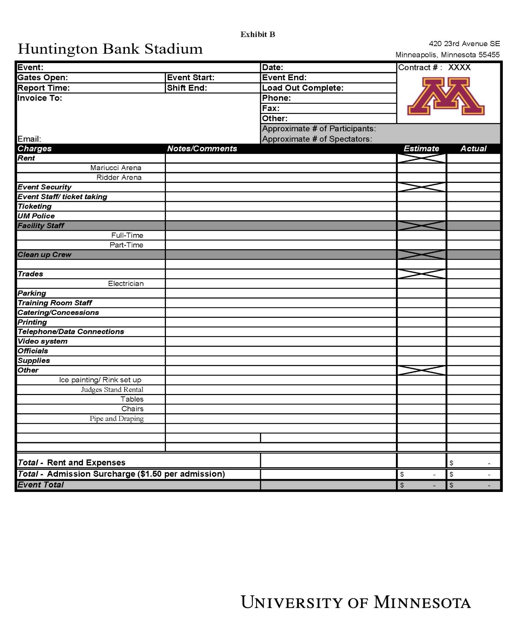

EXHIBIT C
TO
FACILITY USE AGREEMENT

If the Event is ticketed, ticket sales will be conducted by:

University Licensee or Licensee’s vendor

A. Ticket Sales by University.

(1) Tickets to the Event will be available on the date(s) of the Event at the Facility Ticket Window ( ) hours prior to and until thirty (30) minutes after the start of the Event.

(2) University will print and provide to Licensee Event tickets for Licensee’s pre-sales, if requested by Licensee. All tickets sales will be at the printed face value on the ticket.

(3) There will be no refunds on ticket sales unless the Event is canceled by Licensee or for an Uncontrollable Event. If the Event is canceled, refunds will be made to purchasers in the same manner as their payment was made and for the full amount of the order, including the processing fee.

(4) University will hold funds from University ticket sales until after the Event. University will provide a report of all tickets sales to Licensee and, based on the report, distribute net proceeds to Licensee within ( ) days after the Event. “Net proceeds” is defined as ticket receipts held by University, minus the Total Fee and ticketing fee.

B. Ticket Sales by Licensee.

(1) Licensee agrees that it will not sell more tickets than ( ) tickets to the Event.

(2) Licensee’s selection of a ticket vendor must be approved in advance by University.

(3) Licensee or its vendor may use the Facility Ticket Office to conduct ticket sales at the Facility Ticket Window not earlier than ( ) hours prior to and until thirty (30) minutes after the start of the Event. The fee for use of the Facility Ticket Office is included in Exhibit B.

(4) Pre-sales of tickets to the Event will be the sole responsibility of Licensee or its vendor.

(5) Licensee will be solely responsible for refunds on ticket sales conducted by License or its vendor if the Event is cancelled.
(6) Subject to applicable law, Licensee shall not sell or consign tickets to third parties for the purpose of reselling such tickets to the public unless mutually agreed by University and Licensee in writing and in advance of such sales.

C. Ticketing Fees.

(1) University will collect a ticketing fee in the amount of and /100 dollars ($ ) for each ticket sold to the Event. If Licensee or its vendor conducts ticket sales, the ticketing fee will be included as a Licensee charge in Exhibit B.

(2) If University conducts ticket sales, in addition to the ticketing fee, University will be entitled to collect the following from Licensee:

a. A processing fee of and /100 dollars ($ ) for group orders;
b. A processing fee of and /100 dollars ($ ) per ticket for complimentary tickets;
c. Three percent (3%) of gross ticket sales; and
d. One and NO/100 dollars ($1.00) per refunded ticket in case of Event Cancellation.

