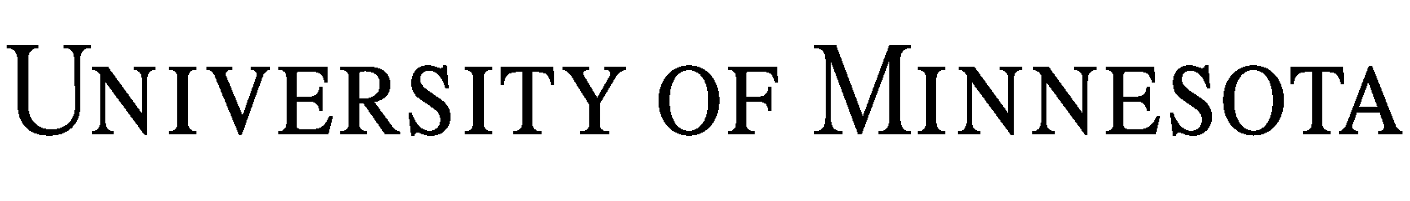

RELEASE OF LIABILITY – FIELD TRIP

I wish to participate in the field trip(s) associated with the offered by the University of Minnesota (the “Activity”). I knowingly and voluntarily assume the risk of any injuries, regardless of severity, and including death, and all risk of damage to or loss of property that I may incur due to negligence or accident while I am participating in these field trips.

I understand that, by participating in the Activity I may be exposed to COVID or another communicable disease (“Disease”). By participating in the Activity, I assume the risk for me, my personal representatives, heirs, and next of kin, that I will be exposed to and contract a Disease and, if that were to happen, that I may require hospitalization or other medical treatment and may be temporarily or permanently injured or disabled or may die. I also assume the risk that I could pass the Disease to others. I agree to take reasonable steps to lessen my risk of exposure to a Disease. By participating in the Activity, I warrant that, to my actual knowledge, I and any individuals living with me are not infected with a suspected, diagnosed, or confirmed case of a Disease and are not exhibiting symptoms of a Disease. I also warrant that I have not been directed to quarantine or isolate at any point during the duration of the Activity. If at any point during the duration of the Activity I am directed to quarantine or isolate, I will stay home, and I will not be entitled to a refund in any amount.
I also understand that public health conditions or state or federal guidance may change at any time, necessitating a modification to or a cancellation of the Activity. In the event of a modification to or cancellation of the Activity, the University will communicate with me as promptly as possible and share options for participation in the Activity. If the Activity is cancelled before its completion, I may receive a prorated refund after non-recoverable expenses are paid.
In consideration for the opportunity to participate in this Activity, I, on behalf of myself, my agents, heirs, and next of kin, hereby release the Regents of the University of Minnesota, its and their respective employees, agents, members, and representatives and, if applicable, owners and lessors of premises used to conduct the event (“Releasees”) from any responsibility or liability for personal injury, including death, and damage to or loss of property that I may incur due to negligence of the groups named above or my own negligence or due to accidental occurrences while I am traveling to or from, engaged in, or otherwise participating in this Activity.

The laws of the state of Minnesota shall govern the validity, construction and enforceability of this Agreement, without giving effect to its conflict of laws principles. All suits, actions, claims and causes of action relating to the construction, validity, performance and enforcement of this Agreement shall be in the courts of the State of Minnesota.

I certify that to my knowledge there is no medical reason why I cannot safely participate in this Activity.

By:
Name:
Phone Number:
Date:

NOTICE
Participants under 18 years of age must have this release co-signed by their parent or guardian.

This is to certify that I, as parent/guardian with legal responsibility for this participant, do consent and agree to release as provided above of all the Releasees, and, for myself, my heirs, assigns, and next of kin, I release and agree to indemnify and hold harmless the Releasees from any and all liabilities incident to my minor child’s involvement or participation in these programs as provided above, EVEN IF ARISING FROM THE NEGLIGENCE OF THE RELEASEES, to the fullest extent permitted by law.

By:
Name:
Phone Number:
Date:

