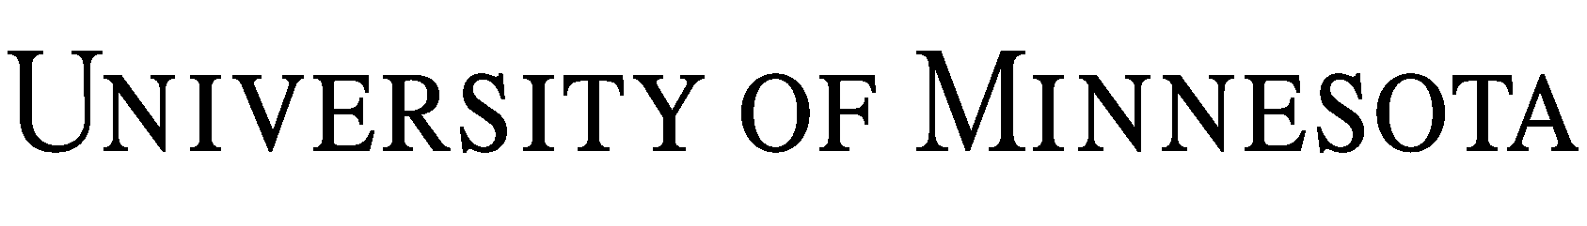
ADDENDUM
TO THE SERVICES AGREEMENT
DATED
BETWEEN
REGENTS OF THE UNIVERSITY OF MINNESOTA (“UNIVERSITY”)
AND

(“COMPANY”)

The parties set forth above hereby agree that the terms of this Addendum shall be incorporated in and be a part of that certain Services Agreement, as referenced above (the “Agreement”).

1. The following is hereby added as a new Section 11:

11. Confidentiality.

11.1. For purposes of this Agreement, “Confidential Information” means written or tangible information disclosed by either party to the other, which at the time of disclosure, is clearly and conspicuously labeled “Confidential” or “Proprietary”. Confidential Information shall also mean oral and visual disclosures which are identified as confidential at the time of such disclosures and which are confirmed and summarized within fifteen (15) days of the disclosure by the disclosing party in a written document that sets forth the substance of the Confidential Information disclosed. The parties acknowledge that this Agreement is a public record and may be released to third parties in compliance with Minnesota law.

11.2. The parties agree not to disclose the other’s Confidential Information to third parties during the term of this Agreement, including any renewal periods, and for a period of three (3) years from the effective termination or expiration date of this Agreement. Each party may disclose the other party’s Confidential Information only to employees requiring access thereto for the purposes of this Agreement. Furthermore, neither party shall use said Confidential Information for any purpose other than those purposes specified in this Agreement. Neither party shall be held financially liable for any inadvertent disclosure, but each will agree to use its reasonable efforts not to disclose any agreed to Confidential Information.

11.3 Nothing contained herein will in any way restrict or impair either party’s right to use, disclose, or otherwise deal with any Confidential Information that at the time of its receipt:

11.3.1 Is generally available in the public domain, or thereafter becomes available to the public through no act of the receiving party;

11.3.2 Was independently known prior to receipt thereof, or made available to such receiving party as a matter of lawful right by a third party;

11.3.3 Is received without obligation of confidentiality from a third party who was free to disclose the information; or

11.3.4 Is required by law (including disclosures under the Minnesota Government Data Practices Act, Minnesota Statutes, Chapter 13), regulation or court order to be disclosed.

2. The following language is added as a new Section 12:

12. Results of Analysis and Intellectual Property Rights. The parties acknowledge that University may use the results of the Services to guide the design of broader research activities. Any materials or information provided to University under this Agreement shall remain the property of Company and Company grants University no express or implied intellectual property rights in such information or materials.

3. Except as expressly provided herein, all other provisions of the Services Agreement shall remain the same.

IN WITNESS WHEREOF, the parties have entered into this Addendum as of the dates indicated below. Each individual signing below represents that they have the authority to bind the party on whose behalf they are signing.

Regents of the University of Minnesota  By:  Name:  Title:  Date: | By:  Name:  Title:  Date:

